Research Proposal
Title of Proposed Research Project : |  | Optimization of Aircraft Landing Problem Using Soft Computing Approach.
Project Leader : |  | Ms Norhidayah Mohamad
Faculty : |  | Faculty of Engineering and Technology
Grant/Cycle: |  | Mini Fund 2017/2018
(A) Research Background including Hypothesis /Research Questions and Literature Reviews
Background

Over the years, air traffic congestion has been a serious issue. This congestion is caused by number of factors including high traffic volume, flight delays, runway allocation, weather change and workload of controller. Various techniques have been implemented in order to reduce the implication of this problem. The optimal scheduling of aircraft landing sequence is known as the Aircraft Landing Problem (ALP) and belong to operational research area. In this project, Gravitational Search Algorithm (GSA), is considered for sequencing and scheduling group of arriving flights. GSA, is a population-based optimization algorithm inspired by gravitational phenomenon. GSA has been proven to be able to provide optimal solution for many applications.

Problem Statement

Air traffic controller (ATC) or most often called the controller, is responsible in handling off-ground flight operations. One of many tasks of the controller is to manage the flights once they entered the designated airspace. The task of planning (sequencing and scheduling) the arriving banks of flights is handled by controller based on their years of training. This task is also known as aircraft landing problem (ALP). ALP needs to be solved within specific amount of time as it deals with a lot of parameters, such as numbers of runways available, the separation time constraint, the fuel costs, the present weather and many more. This is high pressure workload for the controller. Hence, this project proposed to to assist the planning process with soft computing approach. This approach is not only able to reduce the workload of the controllers but it is also able to reduce human error in making decision which can be fatal. Soft computing approach, particularly GSA is suitable for this task due to the low complexity of the algorithm.

Literature reviews

Previous assessment of (Yifei & Kai, 2010) on air traffic congestion identified the key indicators that leads to the problem. Those key indicators are the saturation of air traffic units, the queuing vehicles, flight delays, working load of air traffic controllers and the flight speed. Air traffic congestion has to be controlled or else, poor management of this congestion may lead to a lot of flight delays, increase of operational errors by air traffic control controllers and passengers’ dissatisfaction.

Flight delays as one of main key indicators that is need to be managed. Flight delays is caused by the poor management of air traffic controller in making the scheduling of the landing flights. There are two types of delay, take-off delays and landing-time delay. Landing-time delay is more costly that the take-off delay (Yu & Yang, 1999).

In previous work of (Cheng, Crawford, & Menon, 1999), the runway assignment is carried using genetic search algorithm. This paper emphasize the use of 4 schemes of genetic search to solve a simple scenario involving 12 flights in 3 runways. The result show an impressive result using the algorithm.

The ALP is approached from a different perspective in (Beasley, Krishnamoorthy, Shairaiha, & Abramson, 2000). They introduced a mixed-integer zero–one formulation of the problem for the single runway case and extended it to the multiple runway case. They combined the formulation with basic tree search to strengthen the linear programing relaxation of these formulations. The scenario which uses 50 aircraft and 4 runways is tested and the result showed the heuristic algorithm are able to work with various constraints that commonly encountered in practice.

Another work of Beasley in (Pinol & Beasley, 2006) consider the same problem using scatter search combined with bionomic algorithm. In this paper, the problems are defined in two type of objective functions; linear and non-linear. Computational results are presented for 13 instances involving 10 to 500 aircraft. The number of runways is varied and the objective adopted for these 13 instances means in total 101 problems. Based on the computational results, for linear objective functions, scatter search would perform better than bionomic algorithm. While in the case of non-linear objective, bionomic algorithm would outperform scatter search.

In (Beasley, Sonander, & Havelock, 2001), population-based heuristic (PH) approaches is considered to solve aircraft landing time. When using PH algorithm, the nature of the objective function, whether it is linear or nonlinear, is irrelevant in terms of the solvability of the problem. Previous literature shows that a number of varying constraints could be an issue in determining the objective function and needed to be solved with different algorithm, while using PH, it is relatively easy. Hence, it is rather favoured feature of the algorithm developed in solving the problem.

Another population based algorithm used is Particle Swarm Optimization (PSO). PSO is one of the popular metaheuristic algorithm used in optimizing a given problem by iteratively moving a set of candidate solutions in the search space in pursuit of finding an optimal solution with regard to a given objective function. Example of PSO application in solving ALP problem is in hybrid particle swarm optimization-local search (HPSO-LS) by (Girish, 2016). This paper describes a hybrid PSO that uses permutation-based particle position representation scheme coupled with local search. The algorithm is s evaluated on a set of benchmark instances involving up to 500 aircrafts and 5 runways.

(Lieder, Briskorn, & Stolletz, 2015) present a paper on ALP considering the aircraft classification. The technique used is dynamic programming based on the formulation derived from another work of Briskorn. A new dominance criterion is developed in the paper for state space reduction by which can reduce computation times significantly, proven that the numerical experiments show that problems with up to 100 aircrafts can be optimally solved within seconds

Research Gap Analysis

From the literature reviews conducted it can be seen that soft computing approach is not popular yet in solving ALP. GSA which was introduced in 2009 by Rashedi et. al. (Rashedi, Nezamabadi-pour, and Saryazdi 2009), is found to be more superior to some well-established optimization algorithms, such as Central Force Optimization (CFO), Genetic Algorithm (GA) and Particle Swarm Optimization (PSO) (Rashedi, Nezamabadi-pour, and Saryazdi 2009). GSA was found to outperform other algorithms in solving the cell placement problem of VLSI circuits design process (Eldos and Qasim 2013), synthesis of scanned thinned array in (Chatterjee, Mahanti, and Pathak 2010) placement of distributed generator in renewable energy system (Uniyal & Kumar, 2016) and suppression of background noise in speech signal (Prajna, Reddy, Rao & et.al., 2015). The main attraction of GSA is due to its simplicity which requires only two parameters tuning as compared to other algorithms. Therefore, the application of soft computing approaches in particular GSA in solving ALP is to be investigated in this project.

References

- E. Rashedi, H. Nezamabadi-pour, and S. Saryazdi, “GSA: A Gravitational Search Algorithm,” Inf. Sci. (Ny)., vol. 179, no. 13, pp. 2232–2248, Jun. 2009.
- T. Eldos and R. Al Qasim, “On The Performance of the Gravitational Search Algorithm,” vol. 4, no. 8, pp. 74–78, 2013.
- A. Chatterjee, G. Mahanti, and N. Pathak, “Comparative performance of gravitational search algorithm and modified particle swarm optimization algorithm for synthesis of thinned scanned concentric ring array,” Prog. Electromagn, September 2010, pp. 331–348, 2010.
- Uniyal and A. Kumar, "Comparison of optimal DG placement using CSA, GSA, PSO and GA for minimum real power loss in radial distribution system," 2016 IEEE 6th International Conference on Power Systems (ICPS), New Delhi, 2016, pp. 1-6.
- Prajna, K., Reddy, K.V.V.S., Rao, G.S.B. et al. A comparative study of BA, APSO, GSA, hybrid PSOGSA and SPSO in dual channel speech enhancement Int J Speech Technol (2015) 18: 663
- Y. Zhao and K. Chen, “Air traffic congestion assessment method based on evidence theory,” 2010 Chinese Control Decis. Conf., pp. 426–429, 2010.
- G. Yu and J. Yang, “Optimization Applications in the Airline Industry,” Handbook, pp. 1–92, 1998.
- V. H. L. Cheng, L. S. Crawford, and P. K. Menon, “Air traffic control using genetic search techniques,” Proc. 1999 IEEE Int. Conf. Control Appl. (Cat. No.99CH36328), vol. 1, pp. 249–254, 1999.
- J. E. Beasley, M. Krishnamoorthy, Y. M. Sharaiha, and D. Abramson, “Scheduling Aircraft Landings — The Static Case,” Transp. Sci., vol. 34, no. 2, pp. 180–197, 2000.
- H. Pinol and J. E. Beasley, “Scatter Search and Bionomic Algorithms for the aircraft landing problem,” Eur. J. Oper. Res., vol. 171, no. 2, pp. 439–462, 2006.
- J. E. Beasley, J. Sonander, and P. Havelock, “Scheduling aircraft landings at London Heathrow using a population heuristic,” J. Oper. Res. Soc., vol. 52, no. 5, pp. 483–493, 2001.
- G. B.S., “An efficient hybrid particle swarm optimization algorithm in a rolling horizon framework for the aircraft landing problem,” Appl. Soft Comput., vol. 44, pp. 200–221, 2016.
- D. Briskorn and R. Stolletz, “Aircraft landing problems with aircraft classes,” J. Sched., vol. 17, no. 1, pp. 31–45, 2014.

(B) Objective(s) of the Research
- To investigate ALP and formalized the problem into an optimization model.
- To analyse and apply the soft computing approach such as Gravitational search algorithm and Particle swarm optimization in solving ALP using simulation.
- To develop an ALP optimization software with a user friendly GUI to aid air traffic controller in the complex task of seqencing and scheduling group of arriving flights.
- To raise awareness in using automation system in air traffic control.

(C) Methodology
C(i) | Description of Methodology
C(i) | - Definition of research problem  The ALP is mathematically formulated and the constraints are identified.  - Literature review  To conduct comprehensive literature review on the topics and identified existing methods for comparison with proposed methods  - Algorithm development  Implementation of GSA for ALP problem.  - Data collection & analysis  The efficiency of the proposed algorithm will be compared with existing methods. This will be done using benchmark data (http://people.brunel.ac.uk/~mastjjb/jeb/orlib/airlandinfo.html) and using real data of KLIA which is obtained from Department of Civil Aviation Malaysia.  Statistical analysis will be performed.  - Report  Output of the research is to be reported in term of journal and conference proceedings.
C(ii) | Flow Chart of Research Activities
C(ii) | 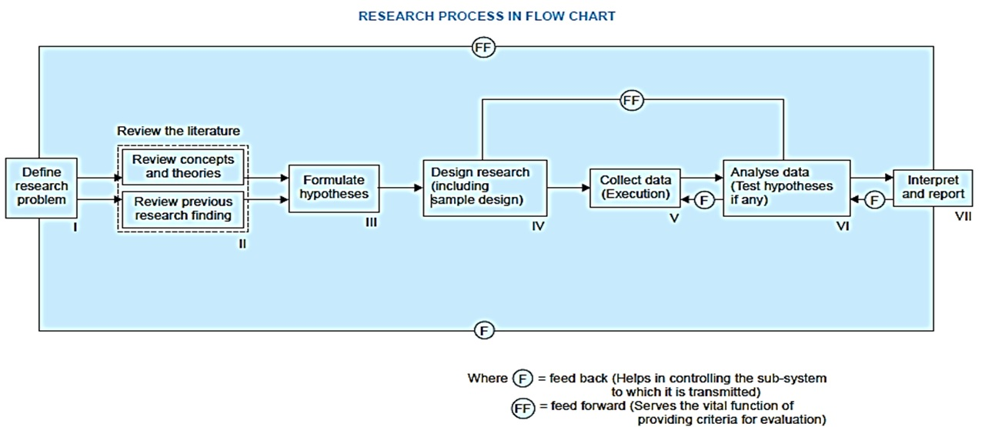
C(iii) | Gantt Chart of Research Activities
C(iii)
  Phase | Research activities | Duration in months | Dec ’16 – Feb ‘17 |  |  | Mar ’17 – Mei ‘17 |  |  | June ’17 – Aug ‘17 |  |  | Sept ’17 – Jan ’18
  Phase | Research activities | Duration in months | Month 1-3 |  |  | Month 4-6 |  |  | Month 7-9 |  |  | Month 10-14
  Introductory | Define research problem | 1
  Introductory | Review literature | 2
  Introductory | Formulate hypothesis | 3
  Research and writing | Design research – algorithm development | 2
  Research and writing | Data collection | 4
  Research and writing | Data analysis | 5
  Research and writing | Reporting of research outcome | 6
  Ongoing | Research progress meeting | 14
  Ongoing | Monthly presentation | 14
C(iv) | Milestones and Dates
C(iv)
  Phase | Research activities | End Dates | Progress
  Introductory | Define research problem | 31 Dec 2017 | 7%
  Introductory | literature review | 31 Jan 2018 | 14%
  Introductory | Formulate hypothesis | 28 Feb 2018 | 21%
  Research and writing | Design research – algorithm development | 30 Apr 2018 | 35%
  Research and writing | Data collection | 31 Aug 2018 | 65%
  Research and writing | Data analysis | 31 Dec 2018 | 90%
  Research and writing | Reporting of research outcome | 31 Jan 2018 | 100%
(D) Expected Results/Benefit
D(i) | Novel theories/New findings/Knowledge
D(i) | As a conclusion, GSA is expected to improve the process of sequencing and scheduling in air traffic control. The solution provided by the proposed algorithm can help air traffic controllers with the process of effective aircraft-landing planning and will reduce their workload, risk of human error and a decrease in traffic congestion in the control area. Among other advantages are minimization of flight delays, fuel consumption by aircrafts, and environmental pollutants.  Output: An ALP optimization software with a user friendly GUI.
D(ii) | Research Publications (Indexed journals)
D(ii) | 1 indexed journal
D(iii) | Significance of your research to your centre/faculty/university
D(iii) | Soft computing algorithms have been successfully applied in various fields of studies from, engineering problems such as power distribution, network routing, VLSI design and swarm robotics to problems such as stock exchange forecast and crowd simulation in crowded area. This research is focusing on an operational research problem, the ALP. ALP is a scheduling problem, therefore the findings of this research is also applicable for many other scheduling problems.  This project is within the focus areas of the special interest group - Engineering Computational Intelligence. The findings have application potential in areas within the faculty’s domains. Furthermore, the project will help to further strengthen MMU’s ranking in the computer science field specifically and the overall ranking in general.

